DESIGN AND ANALYSIS OF ALGORITHMS LAB-2
SORTING TECHNIQUES
NAME:D.CHETAN KUMAR
ROLL NO: CH.SC.U4CSE24209

1.Bubble Sort
Code:
#include <stdio.h>

int main() {
int n, i, j, temp;

printf("Enter number of elements: ");
scanf("%d", &n);

int arr[n];

printf("Enter elements:\n");
for (i = 0; i < n; i++) {
scanf("%d", &arr[i]);
}

for (i = 0; i < n - 1; i++) {
for (j = 0; j < n - i - 1; j++) {
if (arr[j] > arr[j + 1]) {
temp = arr[j];
arr[j] = arr[j + 1];
arr[j + 1] = temp;
}
}
}

printf("Sorted array:\n");
for (i = 0; i < n; i++) {
printf("%d ", arr[i]);
}

return 0;
}
Output:
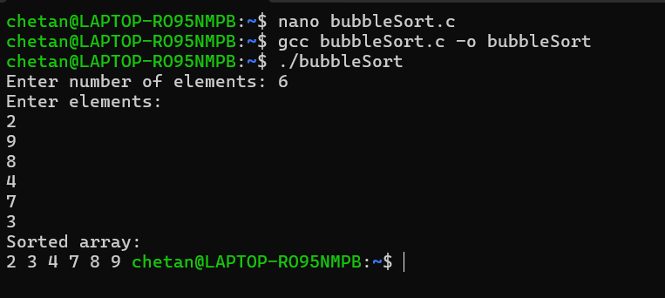
2.Insertion Sort
Code
#include <stdio.h>
int main() {
int n, i, j, key;
printf("Enter number of elements: ");
scanf("%d", &n);
int arr[n];
printf("Enter the elements:\n");
for(i = 0; i < n; i++) {
scanf("%d", &arr[i]);
}

for(i = 1; i < n; i++) {
key = arr[i];
j = i - 1;
while(j >= 0 && arr[j] > key) {
arr[j + 1] = arr[j];
j--;
}
arr[j + 1] = key;
}
printf("Sorted array:\n");
for(i = 0; i < n; i++) {
printf("%d ", arr[i]);
}

return 0;
}
Output
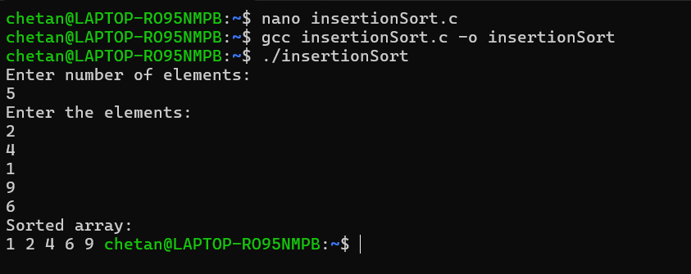

3.Selection Sort
Code
#include <stdio.h>

int main() {
int n, i, j, minIndex, temp;

printf("Enter number of elements: ");
scanf("%d", &n);

int arr[n];

printf("Enter the elements:\n");
for(i = 0; i < n; i++) {
scanf("%d", &arr[i]);
}

for(i = 0; i < n - 1; i++) {
minIndex = i;

for(j = i + 1; j < n; j++) {
if(arr[j] < arr[minIndex]) {
minIndex = j;
}
}

temp = arr[i];
arr[i] = arr[minIndex];
arr[minIndex] = temp;
}

printf("Sorted array:\n");
for(i = 0; i < n; i++) {
printf("%d ", arr[i]);
}

return 0;
}

Output:
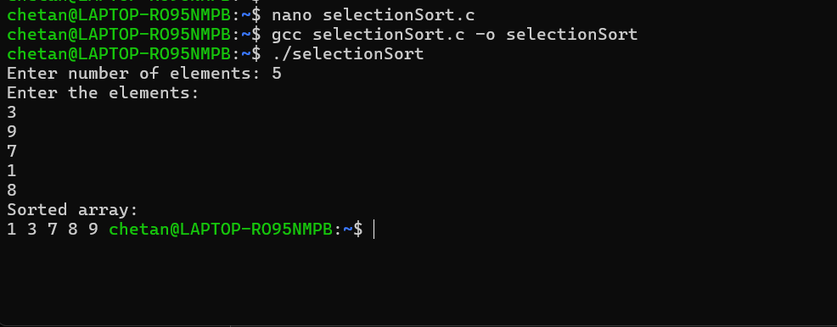
4.Heap Sort
Code:
#include <stdio.h>

void swap(int *a, int *b) {
int temp = *a;
*a = *b;
*b = temp;
}

void heapify(int arr[], int n, int i) {
int largest = i;
int left = 2*i + 1;
int right = 2*i + 2;

if (left < n && arr[left] > arr[largest])
largest = left;

if (right < n && arr[right] > arr[largest])
largest = right;

if (largest != i) {
swap(&arr[i], &arr[largest]);
heapify(arr, n, largest);
}
}

void heapSort(int arr[], int n) {

for (int i = n/2 - 1; i >= 0; i--)
heapify(arr, n, i);

for (int i = n - 1; i > 0; i--) {
swap(&arr[0], &arr[i]);
heapify(arr, i, 0);
}
}

int main() {
int n;
printf("Enter number of elements: ");
scanf("%d", &n);

int arr[n];
printf("Enter elements:\n");
for (int i = 0; i < n; i++)
scanf("%d", &arr[i]);

heapSort(arr, n);

printf("Sorted array:\n");
for (int i = 0; i < n; i++)
printf("%d ", arr[i]);

return 0;
}
Output:
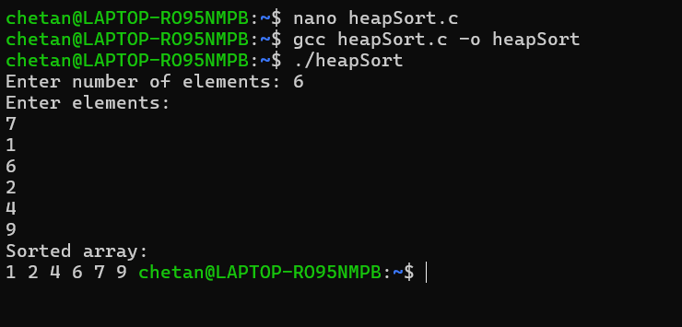

5.Bucket Sort
Code:
#include <stdio.h>
void insertionSort(float arr[], int n) {
for(int i = 1; i < n; i++) {
float key = arr[i];
int j = i - 1;
while(j >= 0 && arr[j] > key) {
arr[j + 1] = arr[j];
j--;
}
arr[j + 1] = key;
}
}
int main() {
int n;
printf("Enter number of elements: ");
scanf("%d", &n);
float arr[n];
printf("Enter elements (0 to 1):\n");
for(int i = 0; i < n; i++)
scanf("%f", &arr[i]);
float bucket[n][n];
int count[n];
for(int i = 0; i < n; i++)
count[i] = 0;
for(int i = 0; i < n; i++) {
int index = n * arr[i];
bucket[index][count[index]++] = arr[i];
}
for(int i = 0; i < n; i++)
insertionSort(bucket[i], count[i]);
int k = 0;
for(int i = 0; i < n; i++)
for(int j = 0; j < count[i]; j++)
arr[k++] = bucket[i][j];

printf("Sorted array:\n");
for(int i = 0; i < n; i++)
printf("%.2f ", arr[i]);

return 0;
}

Output:
